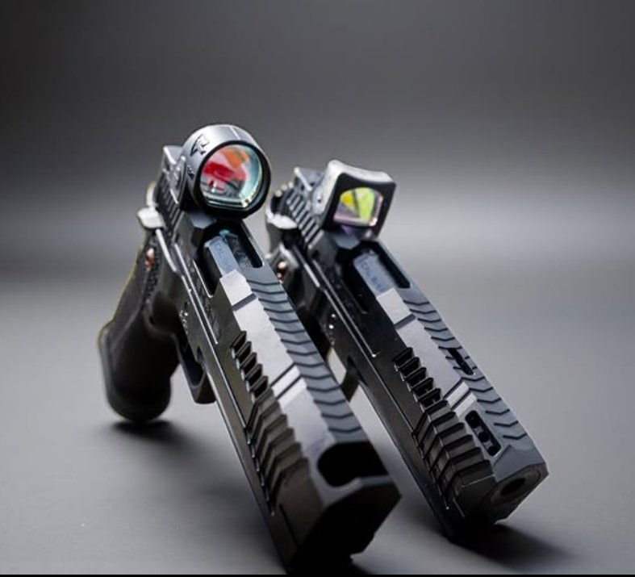

DARK FORGE®
A Shadowed Genesis

1911-DS PLATFORM
Reaper · Wraith®
Owner’s Manual

READ THIS MANUAL THOROUGHLY BEFORE HANDLING THIS FIREARM
Keep this manual with your firearm at all times. If the firearm is transferred to another person, this manual must accompany it.

TABLE OF CONTENTS

QUICK REFERENCE
Ammunition
9x19mm (9mm Luger/Parabellum) only – factory-manufactured, SAAMI/CIP specification. 115-grain and 124-grain copper-jacketed ammunition (FMJ or JHP) recommended for optimal performance. Minimum 130 Power Factor (bullet weight in grains × velocity in fps ÷ 1000). Do not use +P, +P+, reloaded, remanufactured, or hand-loaded ammunition. Reloaded brass is often oversized from SAAMI spec and will hard-jam in the match chamber.
Magazines
Three (3) 140mm magazines included – 21-round capacity where legally permitted, 10-round magazines shipped to capacity-restricted jurisdictions. Use only Dark Forge® supplied magazines or contact support@darkforge.co for replacements.
Maintenance
Clean after every range session – more frequent cleaning will always prolong the tight tolerances and hand-fitted component fitment that define a Dark Forge® pistol. Carbon fouling, copper residue, and debris act as abrasives between precision-fitted surfaces. The more consistently these are removed, the longer your pistol will maintain its factory fit and function. Use quality gun solvent, nylon brushes, cotton swabs, and pipe cleaners for ports and compensator passages. Pay particular attention to the extractor channel, disconnector hole, and firing pin channel. Use cotton swabs for tight areas inside the slide rails.
Lubrication
Use a high-quality gun oil applied sparingly – one drop per contact surface. Key points: slide rails, barrel exterior and cone, reverse plug bore, disconnector channel, frame dustcover rails, and ignition assembly surfaces. Do not oil the compensator, barrel ports, or poppel holes.
Springs
Recoil spring: 8 lb conventional (Reaper) / 9 lb variable (Wraith®). Mainspring: 19 lb (all models). Replace recoil and firing pin springs every 3,000 rounds. All springs are custom-made – purchase exclusively from Dark Forge® at www.darkforge.co.
Warranty
Year One: Muzzle-to-magwell coverage, two-day shipping both ways. After Year One: Limited Lifetime Warranty covering manufacturer defects and premature wear; owner pays shipping to Dark Forge®, two-day return shipping covered. Contact support@darkforge.co to initiate a claim.

Section 1: Safety Information
⚠ WARNING: Firearms can cause serious injury or death. Always treat every firearm as if it is loaded. Failure to follow the safety rules in this manual can result in property damage, serious bodily injury, or death.

1.1 Universal Firearm Safety Rules
- ALWAYS treat every firearm as if it is loaded.
- NEVER point the muzzle at anything you are not willing to destroy.
- Keep your finger off the trigger and outside the trigger guard until your sights are on target and you have made the decision to fire.
- Be certain of your target and what is beyond it before firing.

1.2 Safe Handling Practices
- Always keep the firearm pointed in a safe direction.
- Always keep the firearm unloaded until ready to use.
- Never rely solely on any mechanical safety device. No mechanical safety is a substitute for safe handling practices.
- Do not handle firearms while under the influence of alcohol, drugs, or any substance that may impair judgment or motor skills.
- Never hand a firearm to another person or accept a firearm from another person unless the action is open and you have personally verified that the firearm is completely unloaded.
- Be aware of your surroundings and potential hazards before handling any firearm.
⚠ WARNING: LEAD EXPOSURE: Discharging a firearm generates lead residue and other hazardous substances from the primer, bullet, and propellant. Exposure to lead is known to cause serious health effects, including damage to the nervous system, kidneys, and reproductive system. Always shoot in a well-ventilated area or use proper respiratory protection. Wash your hands and face thoroughly with cold water and soap after handling firearms or ammunition, and before eating, drinking, or touching your face. Do not handle food or beverages while shooting. Clean firearms in a well-ventilated area.

1.3 Ammunition Safety & Recommendations
Dark Forge® pistols are designed to cycle reliably with common factory ammunition at a minimum 130 Power Factor (PF), which equals 1,050 fps with a 124-grain projectile. We recommend 115-grain or 124-grain copper-jacketed 9x19mm factory ammunition for optimal performance. Do not use +P or +P+ ammunition.
- Use only factory-manufactured 9x19mm (9mm Luger/Parabellum) ammunition that meets SAAMI or CIP specifications.
- We recommend 115-grain or 124-grain copper-jacketed ammunition. Loads lighter than 115 grains may not reliably cycle the action or lock the slide back on empty.
- Do not use +P or +P+ ammunition. This firearm is not rated for overpressure loads.
- Never use reloaded, remanufactured, hand-loaded, or otherwise non-standard ammunition. Reloaded ammunition frequently has cases that exceed SAAMI specifications due to brass springing outward after resizing. These oversized cases will wedge into the minimum-spec match chamber during feeding, causing a hard jam that may require a rod to clear. Use of non-standard ammunition voids the warranty and may result in serious injury or death.
- Inspect every round before loading. Do not use ammunition that appears damaged, corroded, dirty, or defective.
- Store ammunition in a cool, dry place, separate from firearms, out of the reach of unauthorized persons.
⚠ WARNING: Use of incorrect caliber ammunition can cause catastrophic firearm failure, serious injury, or death. Your Dark Forge® pistol is chambered in 9x19mm ONLY, as marked on the slide and barrel. ALWAYS verify that your ammunition matches exactly.
⚠ WARNING: SQUIB LOAD / BORE OBSTRUCTION: A squib load is a round that does not generate enough pressure to push the bullet completely out of the barrel. The result is a bullet lodged inside the bore. If you fire a shot and notice significantly reduced recoil, a quieter-than-normal report, or no bullet impact on target, STOP FIRING IMMEDIATELY. Do not chamber or fire another round. Lock the slide to the rear, remove the magazine, and visually inspect the bore from the chamber end for an obstruction. Firing a subsequent round into an obstructed barrel can cause catastrophic barrel failure, destruction of the firearm, and serious injury or death.

1.4 Storage and Security
When not in use, your firearm should be stored unloaded in a secure location, inaccessible to unauthorized persons, especially children. Use a quality gun safe, lock box, or trigger lock. Store ammunition separately from the firearm.
⚠ WARNING: If a locking device is used on this firearm, make absolutely certain the firearm is unloaded before installing the lock. A locking device is not a substitute for safe handling. Installing a locking device on a loaded firearm does not render it safe and can result in an unintended discharge. Never install a trigger lock or cable lock on a loaded firearm.
⚠ WARNING: Do not store firearms in closed cases or containers where moisture can become trapped. Moisture trapped inside a gun case, safe, or sleeve can cause corrosion, pitting, and damage to the DLC/PVD finish and internal components. If storing in a safe, use a dehumidifier or desiccant. After cleaning, ensure the firearm is thoroughly dry before placing it in any enclosed storage.
CAUTION: You may be subject to federal, state, and local laws governing firearm storage. It is your responsibility to know and comply with all applicable laws in your jurisdiction.

1.5 Children and Firearms
⚠ WARNING: Keep all firearms and ammunition out of the reach of children. Educate children about firearm safety. If a child finds a firearm, teach them to: STOP, DON’T TOUCH, RUN AWAY, and TELL AN ADULT.

1.6 Legal Responsibilities
It is your responsibility to understand and comply with all federal, state, and local laws regarding the purchase, ownership, possession, transport, and use of firearms and ammunition. Laws vary by jurisdiction and are subject to change. Consult a qualified attorney if you have questions.

Section 2: Introduction & Features
Congratulations on your purchase of a Dark Forge® pistol. Every Dark Forge firearm is built to the highest standards of precision craftsmanship using premium materials. All components are fully machined – no MIM (Metal Injection Molded) or cast parts are used anywhere in the pistol. Every component is hand-fitted to the individual pistol. Parts are not designed to interchange between pistols – do not attempt to swap components between Dark Forge® firearms without professional fitting. Your pistol has been individually test-fired and inspected before leaving our facility.

2.1 About the Platform
Dark Forge® pistols are built on the double-stack 1911 (1911-DS) platform, a modern evolution of the legendary single-stack 1911 design originally created by John Moses Browning. The 1911-DS architecture combines the proven single-action, recoil-operated mechanism of the classic 1911 with a double-stack magazine well, delivering significantly increased ammunition capacity without sacrificing the ergonomics, trigger quality, and accuracy the platform is known for.

2.2 Model Lineup
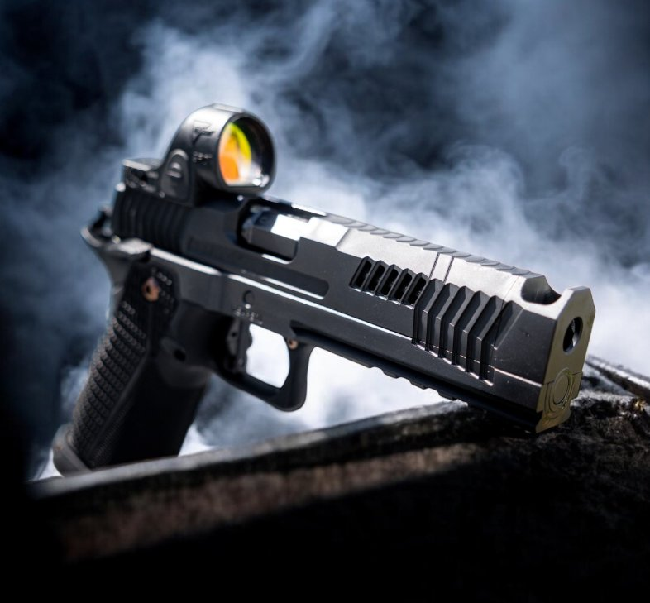

Reaper (Compensated)
The Reaper features a patent-pending integrated one-piece bull barrel and compensator system. The compensator is machined as a single unit with the match-grade bull barrel, eliminating the potential for loosening or misalignment. This one-piece design affords the largest compensator baffles compared to other compensated pistols on the market, maximizing gas redirection and recoil mitigation. The barrel utilizes a cone-style lock-up derived from bullseye shooting disciplines, delivering exceptional accuracy and consistent lockup. Barrel length: 5”.

Reaper Ported (Compensated + Ported)
The Reaper Ported combines the same patent-pending integrated compensator and bull barrel with offset 45-degree V-4 style porting through the slide and barrel and two top poppel holes. This dual-system configuration provides maximum recoil mitigation by combining compensator gas redirection with direct barrel/slide venting. Barrel length: 5”.

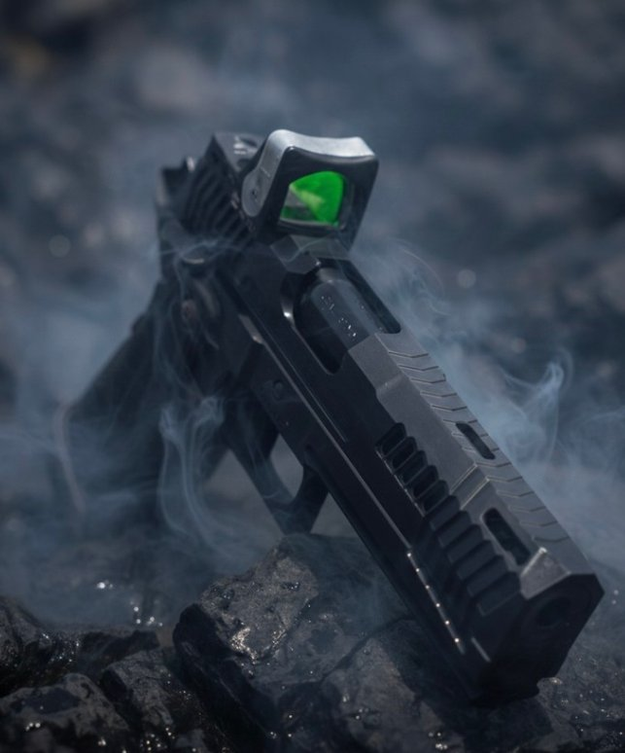

Wraith®
The Wraith® is a compact-profile pistol built on the same patent-pending bull barrel with cone-style lock-up, featuring two top poppel holes and forward V-6 style porting through the slide and barrel. The Wraith® is engineered as a compact platform for fast gun handling that speed shooting demands – delivering rapid target transitions and flat shooting in a shorter package. Barrel length: 4.6”.

2.3 Patent-Pending Bull Barrel System
All Dark Forge® pistols utilize a patent-pending (2026) bull barrel that incorporates a cone-style lock-up system. This design, traditionally found in bullseye competition disciplines, eliminates the barrel bushing entirely. The barrel cone mates directly with the slide, providing a precise and repeatable lock-up that enhances inherent accuracy. The absence of a barrel bushing also simplifies field stripping and reassembly.

2.4 Patent-Pending Grip System
The Dark Forge® grip module features a patent-pending design that nearly eliminates magazine binding during hasty or offset reloads without the use of a corrective magwell. The grip geometry is engineered to naturally guide the magazine into the magazine well from a wide range of insertion angles, dramatically improving reload consistency under stress. The grip module is machined from 7075 aluminum, hard anodized to MIL-SPEC Type III hard black with a Teflon seal for maximum durability and corrosion resistance.

2.5 Proprietary Wide Frame
Dark Forge® pistols feature a proprietary wide frame design that is wider than other production 1911-DS offerings currently on the market, while still accepting standard weapon-mounted lights. The wider dustcover adds mass intentionally – reducing felt recoil and allowing for faster follow-up shots.
CAUTION: Due to the proprietary frame width, Dark Forge® pistols will not fit most standard 1911-DS holsters. Holsters designed specifically for Dark Forge® pistols will be available at www.darkforge.co. Do not attempt to force the pistol into an ill-fitting holster, as this may damage the DLC/PVD finish or interfere with safe holstering and drawing.

2.6 Construction Quality
Every component in a Dark Forge® pistol is fully machined from billet or bar stock. No MIM (Metal Injection Molded) or cast components are used. All parts are hand-fitted to one another. Components are not designed to interchange between individual pistols – do not attempt to swap parts between Dark Forge® firearms without professional fitting. Replacement parts and service should only be obtained from Dark Forge®.

2.7 Standard Features (All Models)
- Caliber: 9x19mm (9mm Luger/Parabellum)
- Heat-treated 4140 carbon steel slide and frame
- DLC/PVD coating for superior wear and corrosion resistance, with PVD Bronze accents
- Patent-pending bull barrel with cone-style lock-up, machined from heat-treated 416R stainless steel, 1:16” twist rate
- Patent-pending 7075 aluminum grip module, MIL-SPEC Type III hard anodized black with Teflon seal
- Non-functional, fixed grip safety
- Gloss black trigger with 2–2.5 lb trigger pull, factory-set (gloss rose gold on select models)
- Fully machined ambidextrous thumb safeties with custom hammer pin that captures the weak-side safety to prevent walk-out during firing
- Stainless steel magwell
- RMR/SRO direct-mount optic cut, low-profile (no iron sights included)
- Full-length guide rod
- Extended ejector with single-lug frame interface for reliable ejection
- Proprietary coil-spring loaded pivoting extractor design
- Lowered and flared ejection port
- Front and rear cocking serrations
- Three (3) 140mm magazines included (21-round capacity)
- Spare extractor caps and extractor coil springs included
- Optic mounting hardware: 4-40 x 3/8” and 4-40 x 7/16” Torx+ (T10+) screws with T10+ Torx bit

2.8 Specifications
NOTE: Specifications below are representative. Refer to the specification card included in your case for exact details specific to your serial number.

Caliber | 9x19mm (9mm Luger/Parabellum)
Operation | Short recoil, locked breech, single action
Frame & Slide | Heat-treated 4140 carbon steel, DLC/PVD coated w/ PVD Bronze accents
Barrel | Heat-treated 416R stainless steel, 1:16” twist, patent-pending bull barrel w/ cone lock-up
Barrel (Reaper Models) | 5.0” (integrated barrel/compensator)
Barrel (Wraith®) | 4.6”
Grip Module | 7075 aluminum, MIL-SPEC Type III hard anodized black w/ Teflon seal
Grip Safety | Non-functional, fixed
Magazine Capacity | 21+1 (three 140mm magazines included; 10-round magazines shipped to capacity-restricted jurisdictions)
Trigger | Gloss black (or gloss rose gold), 2–2.5 lb pull, factory-set
Safety | Fully machined ambidextrous thumb safeties
Optic Mount | RMR/SRO direct mount, low-profile cut (no iron sights)
Guide Rod | Full-length (all models)
Recoil Spring (Reaper) | Gov’t-length, 8 lb conventional wind
Recoil Spring (Wraith®) | Gov’t-length, 9 lb variable wind
Mainspring | 19 lb (all models)
Ejector | Extended, single-lug frame interface
Extractor | Proprietary coil-spring loaded pivoting design
Magwell | Stainless steel
Frame Width | Proprietary wide frame (wider dustcover than other production 1911-DS offerings; accepts standard WML)
Construction | 100% machined components – no MIM or cast parts
Power Factor Rating | 130 PF minimum / 1,050 fps for 124gr (no +P)
Weight (unloaded) | [See specification card]
Overall Length | [See specification card]

Section 3: Nomenclature
Familiarize yourself with the following components. Understanding these parts is essential for safe operation, maintenance, and communication with Dark Forge®.
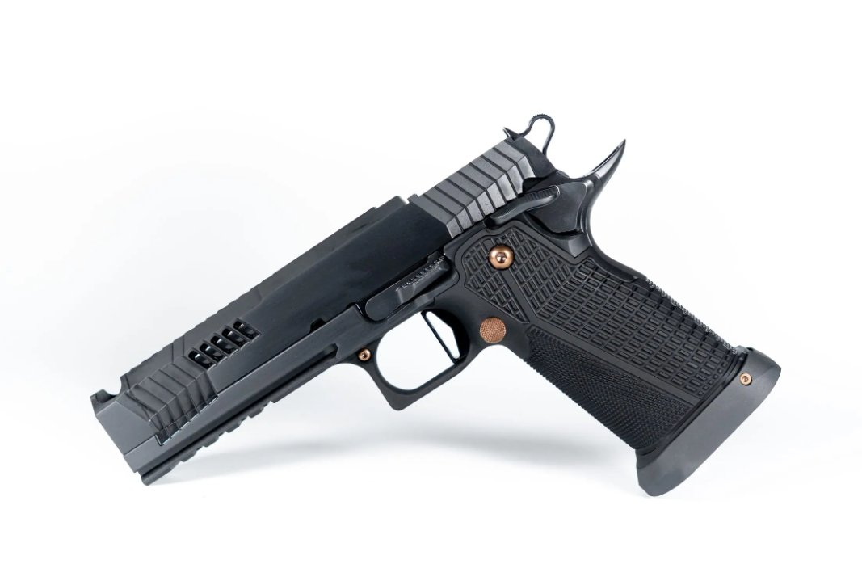

3.1 External Components
- Slide – The upper reciprocating assembly, machined from heat-treated 4140 carbon steel with DLC/PVD coating. Houses the barrel, firing pin, and extractor. On ported models, the slide includes machined porting cuts.
- Frame (Receiver) – The serialized lower component, machined from heat-treated 4140 carbon steel with DLC/PVD coating. Houses the fire-control group. Features a proprietary wide frame design – wider at the dustcover than other production 1911-DS offerings – that adds mass for reduced felt recoil and faster follow-up shots, while still accepting standard weapon-mounted lights.
- Grip Module – The patent-pending 7075 aluminum grip assembly (MIL-SPEC Type III hard anodized black with Teflon seal). Attaches to the frame. Includes a non-functional, fixed grip safety.
- Bull Barrel – The patent-pending rifled barrel, machined from heat-treated 416R stainless steel with a 1:16” twist rate. Uses a cone-style lock-up. Reaper models feature an integrated compensator machined as one piece with the barrel. The Wraith® does not have a compensator.
- Compensator (Reaper models only) – Integrated as one piece with the bull barrel. The one-piece design affords the largest compensator baffles compared to other compensated pistols on the market. Vents gas to reduce muzzle rise.
- Barrel Porting (Reaper Ported / Wraith®) – Machined cuts through the barrel and slide that vent gas upward to further mitigate recoil and muzzle flip.
- Poppel Holes – Top-venting gas ports machined into the barrel and slide.
- Muzzle – The front opening of the compensator.
- Ejection Port – The opening on the right side of the slide where spent casings are ejected.
- Optic Mounting Surface – The milled pocket on top of the slide for direct mounting of an RMR or SRO pattern optic. This is the primary aiming system – no iron sights are included.
- Slide Stop / Slide Release – The lever on the left side of the frame that locks the slide open and releases it.
- Thumb Safety – Fully machined ambidextrous safety levers on both sides of the frame. Engages in the UP position. Utilizes a custom-made hammer pin that captures the weak-side safety to prevent it from walking out during firing.
- Trigger – Gloss black (or gloss rose gold) flat-profile trigger.
- Trigger Guard – The protective loop surrounding the trigger.
- Hammer – The external component at the rear of the slide that strikes the firing pin.
- Magazine Release – The button on the left side of the frame that releases the magazine.
- Magazine – The detachable double-stack magazine holding 21 rounds of 9x19mm ammunition.
- Magwell – The stainless steel flared funnel at the base of the grip.
- Recoil Spring & Full-Length Guide Rod (FLGR) – Located beneath the barrel. Returns the slide to battery after firing. Utilizes a reverse plug.

3.2 Internal Components
- Firing Pin – Strikes the primer of the cartridge to initiate firing.
- Firing Pin Spring – Returns the firing pin after the hammer strikes it.
- Extractor – Proprietary coil-spring loaded pivoting design that grips the cartridge rim and pulls it from the chamber. Uses internal coil springs to provide tension. The factory configuration is one spring in the rear position. Extractor configuration is factory-set – do not alter the spring configuration. Spare extractor caps and springs are included with the pistol.
- Ejector – Extended design with a single-lug interface that mates with the frame. Kicks the spent case out of the ejection port. Replacement ejectors are only available from Dark Forge®.
- Sear – Engages the hammer and releases it when the trigger is pressed.
- Disconnector – Prevents the sear from releasing the hammer until the slide is fully in battery.
- Plunger Tube – Houses the spring and plungers for the thumb safety and slide stop detents.
- Mainspring – 19 lb spring housed in the mainspring housing that powers the hammer.
NOTE: All components are custom-fitted to your individual pistol. Components are hand-fitted and are not designed to interchange between Dark Forge® pistols. Replacement parts and components should only be obtained directly from Dark Forge®.

Section 4: Operation
⚠ WARNING: Before loading or operating this firearm, ensure you have read and understood all safety information in Section 1. Always verify the firearm is unloaded before performing any manipulation other than firing.

4.1 Understanding the Safety Mechanisms
Your Dark Forge® pistol features one manual safety mechanism:
Ambidextrous Thumb Safety – When engaged (UP position), the thumb safety blocks the sear, preventing the hammer from falling. The thumb safety can only be engaged when the hammer is cocked. Always engage the thumb safety when not actively firing. The fully machined ambidextrous design allows operation from either side. The custom-made hammer pin captures the weak-side safety to prevent it from walking out during firing.
⚠ WARNING: The grip safety on this firearm is NON-FUNCTIONAL. It is a fixed element of the grip module. Your only manual safety control is the ambidextrous thumb safety. Always engage the thumb safety when not actively firing.
CAUTION: No mechanical safety is foolproof. Mechanical safeties are supplementary devices and must never be used as a substitute for safe handling practices.

4.2 Condition Codes
- Condition 4 – Chamber empty, magazine removed, hammer down, safety off.
- Condition 3 – Chamber empty, loaded magazine inserted, hammer down, safety off.
- Condition 2 – Round chambered, hammer down (NOT recommended).
- Condition 1 (“Cocked and Locked”) – Round chambered, hammer cocked, thumb safety engaged. Standard carry condition.
- Condition 0 – Round chambered, hammer cocked, thumb safety off. Ready to fire.
⚠ WARNING: Condition 2 (hammer down on a loaded chamber) is NOT recommended. Lowering the hammer manually on a loaded chamber risks an accidental discharge. Dark Forge® recommends Condition 1.

4.3 Loading the Magazine
- Verify the firearm is unloaded and the slide is locked open or the magazine has been removed.
- Hold the magazine with the open end facing up and the bullet end facing forward.
- Place a cartridge on top of the magazine follower with the bullet pointing forward.
- Press the cartridge down and slide it rearward under the feed lips until it snaps into place.
- Repeat until the magazine is loaded to the desired capacity. Maximum capacity is 21 rounds.
NOTE: Your Dark Forge® pistol ships with three (3) 140mm magazines. A quality speed loader is recommended to reduce thumb fatigue when loading to full capacity.

4.4 Loading the Pistol
⚠ WARNING: Always point the firearm in a safe direction during loading. Keep your finger off the trigger and outside the trigger guard.
- Verify the pistol is in Condition 4.
- Insert a loaded magazine firmly into the magwell until it clicks and locks. Tug gently to verify it is seated.
- Grasp the rear of the slide firmly. Pull fully to the rear and release sharply. Do not ride the slide forward.
- The pistol is now loaded with a round in the chamber and the hammer cocked. Engage the thumb safety (UP) immediately. The pistol is now in Condition 1.
CAUTION: Do not ease the slide forward or “ride” it closed. This can cause a failure to feed or failure to go fully into battery. Additionally, never repeatedly drop or slam the slide forward on an empty chamber. Doing so causes unnecessary impact stress on the barrel, slide, and locking surfaces and can accelerate wear and peening over time.

4.5 Recommended Grip Technique
Dark Forge® pistols are designed to be fired using a thumbs-forward grip with the strong-hand thumb riding the thumb safety. This grip provides optimal recoil control, consistent safety manipulation, and prevents common malfunctions associated with improper hand placement.
Strong Hand: Grip the pistol as high on the backstrap as possible, with the web of the hand seated firmly into the beavertail grip safety. Wrap the lower three fingers around the front strap with firm, even pressure. The trigger finger rests alongside the frame until ready to fire. The strong-hand thumb rests on top of the thumb safety paddle, pointing forward, holding the safety in the depressed (fire) position.
Support Hand: Wrap the fingers of the support hand around the strong hand, filling the gap on the left side of the grip. The support-hand thumb extends forward alongside the frame, below and parallel to the strong-hand thumb. The heel of the support hand should make full contact with the exposed grip surface. Apply approximately 60% of total grip pressure with the support hand.
⚠ WARNING: Your grip must not interfere with the movement of the slide during operation. Neither thumb should contact the slide at any point. Thumb contact with the slide during cycling can slow or stop the slide, causing failures to eject, failures to feed, and failures to lock back on an empty magazine.
⚠ WARNING: The strong-hand thumb must remain on top of the thumb safety paddle – not below it. If the thumb slips below the paddle, the web of the hand can push the bottom of the safety paddle upward during recoil, driving it into the underside of the recoiling slide. This causes damage to both the thumb safety and the slide, and can also cause failures to eject and failures to lock back.
CAUTION: If you experience failures to eject or failures to lock back, fire one round strong hand only. If the malfunction does not occur, the issue is likely grip-related. Adjust your grip so that no part of the hand or thumb impedes slide travel or contacts the thumb safety from below.

4.6 Firing
- Ensure you are in a safe environment suitable for firing.
- Acquire a proper firing grip: wrap the shooting hand high on the backstrap, web of the hand firmly against the beavertail.
- Disengage the thumb safety by sweeping it DOWN.
- Align your optic dot on target. If no optic is installed, install an optic before live fire.
- Press the trigger smoothly and steadily to the rear.
- After each shot, the slide will cycle automatically.
- When the last round has been fired, the slide will lock open, indicating the magazine is empty.

4.7 Unloading the Pistol
⚠ WARNING: Always point the firearm in a safe direction. Keep your finger off the trigger.
- Press the magazine release and remove the magazine.
- Pull the slide fully to the rear to eject any chambered round. Lock the slide open.
- Visually and physically inspect the chamber, magazine well, and breech face to verify the pistol is completely empty.

4.8 Clearing Malfunctions
Malfunction clearing is a standard part of firearm operation. If the pistol fails to fire or experiences a stoppage, keep the muzzle pointed in a safe direction and follow the appropriate procedure below.

Failure to Fire (Click, No Bang)
- Keep the muzzle pointed in a safe direction (downrange) and wait a minimum of 30 seconds. DO NOT open the action during this waiting period. A hang fire (delayed ignition) can occur when the primer or powder charge ignites after a noticeable delay. Opening the action during a hang fire can result in a round discharging outside the chamber, causing serious injury or death.
- If no discharge occurs, lock the slide to the rear, remove the magazine, and eject the unfired round.
- Inspect the primer. A light or off-center strike may indicate a mechanical issue. Also inspect the firing pin channel for fouling, as debris can impede the firing pin.

Failure to Feed
If the slide does not fully close on a new round: tap the base of the magazine firmly, then rack the slide fully to the rear and release. If the problem persists, possible causes include: an optic mounting screw on the extractor side that is too long and impinging on the extractor’s ability to pivot; too much threadlocker (Vibra-Tite 122) applied to the extractor-side optic screw, which can migrate and restrict the pivoting extractor; weak magazine springs; a fouled extractor channel; weak or worn recoil springs; out-of-spec ammunition (oversized cases or improper crimp – common with reloaded brass); weak ammunition below 130 PF that fails to fully cycle the slide; an improper grip that contacts the slide during cycling, preventing it from traveling fully into battery; or excessive extractor tension (extractor should require only finger pressure to guide a cartridge rim in and out – approximately 20 oz of tension).

Failure to Eject
If a spent case is caught in the ejection port or not fully ejected: lock the slide to the rear, remove the magazine, clear the stuck case, and reload. Persistent failure to eject may indicate a broken ejector (the extended single-lug ejector can be damaged by improper maintenance), fouled extractor channel; an optic screw impinging on the extractor; underpowered ammunition (below 130 PF); a broken extractor cap; an improper grip (limp-wristing) that absorbs recoil energy and prevents the slide from cycling with enough force to eject the spent case; a thumb or finger contacting the slide during cycling, physically impeding its travel; or the strong-hand thumb positioned below the thumb safety paddle, allowing the paddle to be driven upward into the recoiling slide.

Failure to Lock Back on Empty Magazine
If the slide does not lock open after the last round: this may be caused by ammunition that does not meet the 130 PF minimum, the shooter’s grip interfering with the slide’s travel (including thumb contact with the slide or the strong-hand thumb positioned below the thumb safety, allowing the paddle to be pushed into the recoiling slide), weak magazine springs, or damaged magazines. To test slide lock-back for any given ammunition and magazine combination, fire one round strong hand only. If the slide locks back reliably strong hand only, the issue is likely grip-related.
CAUTION: If any malfunction – failure to feed, failure to eject, or failure to fire – is repeatable with quality 115-grain or 124-grain copper-jacketed factory ammunition, stop firing and contact Dark Forge® for service. Any repeatable malfunction with quality ammunition should be remedied by Dark Forge®.

Section 5: Optic Mounting
⚠ WARNING: Optic mounting screw selection and installation are critical. Improper screw length can impinge on the internal pivoting extractor, causing feeding and extraction failures, or cause other malfunctions.

5.1 Included Hardware
- 4-40 x 3/8” Torx+ (T10+) screws (4)
- 4-40 x 7/16” Torx+ (T10+) screws (4)
- T10+ Torx bit (1)

5.2 Screw Engagement Verification
Before installation, insert the mounting screw through the optic without the slide installed and count the number of visible threads protruding past the optic body. A maximum of 3–4 threads should be showing. If more threads are visible, the screw is too long and may cause a malfunction by impinging on the extractor.
⚠ WARNING: If more than 3–4 threads are visible past the optic body, DO NOT install the screw. Use a shorter screw. An overly long screw can impinge on the internal pivoting extractor, restricting its ability to move. This directly affects feeding and extraction reliability.

5.3 Extractor Tension Test
Dark Forge® requires that you test extractor tension before and after optic installation:
- Before installing the optic, test the extractor tension by sliding a cartridge rim under the extractor claw. Proper tension is approximately 20 oz – you should be able to guide a cartridge rim into and out of the extractor with finger pressure only. If excessive force is required to insert or remove the cartridge, the extractor tension is too high and may cause failures to feed. Note the resistance.
- Install the optic and screws per the procedure below.
- After installation, test extractor tension again using the same method.
- If extractor tension has increased after optic installation, this indicates that the screw is too long and is impinging on the extractor’s ability to pivot freely. Remove the optic and use a shorter screw.
⚠ WARNING: Increased extractor tension after optic installation is a clear indicator that the optic screw is too long. Firing the pistol in this condition can cause failures to feed and failures to extract. This must be corrected before firing.

5.4 Installation Procedure
- Apply blue oil-tolerant Vibra-Tite 122 threadlocker to the screw hole and mounting screw. CRITICAL: Apply very sparingly – use the absolute minimum amount, especially on the extractor side. Excess Vibra-Tite 122 on the extractor-side screw is one of the most common causes of malfunctions on this platform. The threadlocker can wick into the pivoting extractor channel and restrict extractor movement, causing persistent feeding and extraction failures that are difficult to diagnose.
- Place the optic onto the slide, aligning the mounting holes.
- Thread the screws by hand using the included T10+ Torx bit to ensure proper engagement. Do not cross-thread.
- Tighten screws to a maximum torque of 15 in/lbs. Do not exceed this value.
- Verify the optic is seated firmly and does not shift or rotate.
- Perform the extractor tension test described in Section 5.3. Additionally, feed a dummy round (snap cap) from a loaded magazine before and after installing the extractor-side optic screw. If the dummy round feeds smoothly before installation but binds or fails to feed after, the screw is too long and is threading into the extractor channel. This will cause failures to feed and/or erratic ejection. Try the shorter screw on the extractor side, or contact support@darkforge.co.
- Perform a function check and confirm zero at the range before relying on the optic.
CAUTION: Installation and use of this product constitute acknowledgment that the end user or installer assumes all responsibility for verifying correct screw selection, thread engagement, torque values, extractor tension, and post-installation function checks. Professional installation is strongly recommended.

5.5 Optic Compatibility Notice
⚠ WARNING: At this time, Dark Forge® does not recommend the Holosun 507 Comp optic for use on Dark Forge firearms. Industry feedback and internal testing have demonstrated that this optic may lack sufficient elevation adjustment to properly zero at 25 yards on our platform.
Dark Forge® pistols are cut for direct mounting of Trijicon RMR and SRO optics, which have been tested and verified on our platform. While other optics with an RMR footprint may physically mount, Dark Forge® does not guarantee that all RMR-footprint optics will mount and zero correctly. The Holosun 507C has been found to work on a case-by-case basis. No iron sights are included – the optic is the primary aiming system. Dark Forge® strongly recommends installing an optic before live fire. Contact support@darkforge.co with compatibility questions.
NOTE: Dark Forge® pistols feature an ultra-low RMR-footprint optic mount – the lowest in the industry. Some optics may run out of elevation adjustment when zeroing on this platform. If your optic cannot achieve a proper zero in elevation, a 1-degree shim installed between the optic and the slide will raise the optic sufficiently to bring it into the elevation adjustment range. Commercially made 1-degree RMR-footprint shims are widely available from aftermarket optic accessory suppliers.

Section 6: Disassembly, Cleaning & Maintenance
⚠ WARNING: Before disassembly, ALWAYS verify the firearm is completely unloaded. Remove the magazine, lock the slide open, and visually and physically inspect the chamber.

6.1 Field Stripping (Basic Disassembly)
Field stripping requires only a small L-shaped paperclip or similar wire to capture the full-length guide rod assembly. The tool should be approximately 2.5–3” in straight length with about a 1/8” 90-degree bend at one end (see diagram below). No other tools are required. No sight removal is necessary – Dark Forge® pistols do not include iron sights.
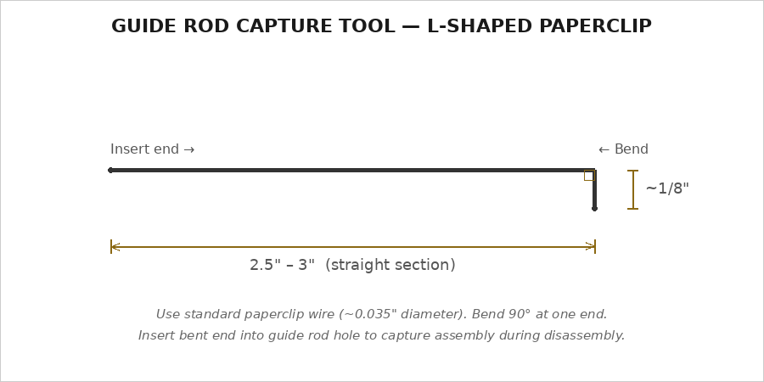
- Verify the pistol is completely unloaded (see Section 4.7). Remove the magazine. Visually and physically confirm the chamber is empty.
- Lock the slide to the rear using the slide stop.
- Move the slide rearward to align the takedown notch – the smaller of the two notches on the left side of the slide – with the slide stop pin.
- With the takedown notch aligned, push inward on the slide stop pin from the right side and withdraw the slide stop from the left side.
- Carefully slide the complete top-end assembly (slide, barrel, and recoil assembly) forward and off the frame rails.
- With the top-end assembly removed, compress the full-length guide rod assembly rearward and insert a small L-shaped paperclip or wire through the hole in the guide rod to capture and hold the recoil spring in its compressed state.
- With the recoil spring assembly captured by the paperclip, remove the recoil spring and full-length guide rod assembly from the slide.
- Remove the barrel from the slide by lifting the rear slightly and sliding it forward and out.
NOTE: There is no barrel bushing on Dark Forge® pistols. The patent-pending bull barrel uses a cone-style lock-up that mates directly with the slide.
⚠ WARNING: The recoil spring assembly is under significant spring pressure. Always wear safety glasses during disassembly. Point the muzzle downward and away from your face when removing the slide assembly. Before disassembly, wipe any oil or grime from the slide and frame surfaces to maintain a secure grip. Do not disassemble the recoil spring assembly from the guide rod except when replacing the recoil spring – there is no reason to separate these components during normal field stripping or cleaning.
⚠ WARNING: Use caution when handling the captured recoil assembly. Pulling on the guide rod or releasing the paperclip prematurely can allow the spring to release with force. Keep fingers clear of the spring’s path of travel and maintain control of the paperclip at all times.

6.2 Reassembly
Always keep the paperclip in the FLGR assembly throughout the entire reassembly process. Removing it too early can release the compressed recoil spring with force and cause the guide rod to come out of alignment with the reverse plug hole, requiring manual realignment. Only remove the paperclip at the very end, with the slide locked back. Use caution – pulling on the guide rod or accidentally dislodging the paperclip at any point during reassembly can release spring pressure unexpectedly.
- Cock the hammer fully to the rear by pulling it back with your thumb. IMPORTANT: Do NOT pull the trigger at any point during reassembly. The hammer must remain cocked.
- Insert the barrel into the slide from the front. Ensure the barrel is fully seated with the barrel cone locked into the slide recess, the link hanging straight down, and the link pin hole visible through the bottom of the slide.
- Insert the captured recoil spring and FLGR assembly (paperclip still in place) into the slide beneath the barrel. The reverse plug must face the muzzle end. Compress the assembly fully forward so the reverse plug sits flush with the front of the slide. The recoil assembly must be compressed all the way forward with the paperclip secure before proceeding – if the assembly is not fully forward, the slide will not seat onto the frame properly.
- With the recoil assembly held fully forward, carefully slide the top-end assembly onto the frame rails from the front.
- Using a small tool such as an Allen key or punch, align the barrel link so the link pin hole lines up with the slide stop hole in the frame.
- Insert the slide stop pin from the left side. It must pass through the frame and through the barrel link. Verify it snaps into the detent.
- Pull the slide to the rear until it locks open on the slide stop (lockback notch).
- With the slide locked back, remove the L-shaped paperclip from the full-length guide rod, releasing the recoil spring assembly.
- Release the slide stop and bring the slide forward to battery.
- Perform a function check: rack the slide several times to verify smooth cycling. Cock the hammer. Verify the thumb safety engages and blocks the trigger on both sides. Disengage and verify the trigger releases the hammer.
⚠ WARNING: If the slide does not return to battery after reassembly, the slide stop pin likely did not pass through the barrel link. Disassemble and verify the barrel link is properly aligned before reinserting the slide stop pin.
CAUTION: Never pull the trigger to drop the hammer during reassembly. Always cock the hammer manually before installing the top end onto the frame. Failure to do so may result in damage to the sear engagement surfaces.

6.2.1 Function Test
Perform a complete function test after every reassembly and before firing. The firearm must be verified unloaded before performing any function test. Remove the magazine, lock the slide to the rear, and visually and physically confirm the chamber is empty.
Thumb Safety Test: Cock the hammer. Engage the thumb safety (UP) on both sides. Pull the trigger – the hammer must not fall. The safety must positively block the sear on both the strong-side and weak-side levers. Disengage the safety and verify the trigger releases the hammer.
Disconnector Test: With the hammer cocked and the slide in battery, push the slide rearward approximately ½” (half an inch) and hold it. Pull the trigger – the hammer must not fall. While still holding the trigger, release the slide forward to battery. Release the trigger – you should hear and feel the disconnector reset (a distinct click). Pull the trigger again – the hammer should now fall. This confirms the disconnector is preventing sear release until the slide is fully in battery.
Half-Cock Test: With the hammer fully cocked, pull the hammer slightly rearward and release it without pulling the trigger. The hammer should catch on the half-cock notch and not fall to the firing pin. If the hammer falls past the half-cock notch to the firing pin, stop and contact Dark Forge® immediately.
Hammer Follow Test: With the hammer cocked, rack the slide briskly and release it. The hammer must not follow the slide forward. If the hammer follows the slide down (falls without the trigger being pulled), STOP IMMEDIATELY – this condition can cause an unintended discharge. Unload the firearm and contact Dark Forge®.
⚠ WARNING: If the firearm fails any function test, do not fire it. Unload the firearm completely and contact Dark Forge® for service at support@darkforge.co.

6.3 Recoil Spring Installation
When installing or replacing the recoil spring, the spring must be properly oriented on the guide rod:
- The closed end (tightly wound, flat end) of the spring goes toward the guide rod head.
- The open end (loose, unfinished end) of the spring faces toward the muzzle.
⚠ WARNING: The recoil spring is under compression when assembled. Always wear safety glasses and maintain control of the spring and guide rod during installation. All replacement recoil springs must be checked for spring stacking before installation. Spring stacking occurs when coils bind against each other before reaching full compression, which can cause cycling issues, premature wear, and potential damage. If spring stacking is detected, contact Dark Forge® or a qualified gunsmith for evaluation and correction. Do not attempt to modify the recoil spring yourself.
NOTE: Shok buffs may be used and should not affect function.

6.4 Recoil Spring & Guide Rod Compatibility
- Reaper models (both): 5” toolless guide rods are compatible as an aftermarket option.
- Wraith®: No factory toolless guide rod is compatible with the Wraith®. Use only the factory FLGR or a Dark Forge® replacement.
NOTE: Recoil spring specifications: Reaper models use a government-length 8 lb conventional wind spring; the Wraith® uses a government-length 9 lb variable wind spring. The mainspring is 19 lb on all models. All replacement springs are custom-made for Dark Forge® pistols. To ensure proper fit and function, purchase replacement springs exclusively from Dark Forge® at www.darkforge.co or by contacting support@darkforge.co.

6.5 Cleaning
Regular cleaning is essential. Ported and compensated models require thorough cleaning of gas passages. Clean after every firing session.

Supplies Needed
- Quality gun solvent / bore cleaner
- Light, high-quality gun oil
- Bore brush (9mm / .355 caliber)
- Cleaning rod or bore snake
- Cleaning patches
- Nylon brush or old toothbrush
- Clean, lint-free cloth
- Pipe cleaners (for ports, poppel holes, and compensator passages)
- Cotton swabs (for slide rail interiors, firing pin hole, and extractor channel)

Cleaning Procedure
- Field strip the pistol (Section 6.1).
- Barrel: Run a solvent-soaked bore brush through from breech to muzzle. Follow with patches until clean. Clean the barrel exterior, chamber, feed ramp, barrel cone, compensator passages, and all ports/poppel holes with solvent and a nylon brush. Use pipe cleaners for port openings.
- Slide: Clean the interior with solvent and a nylon brush. Pay attention to the breech face, extractor channel, firing pin channel, barrel cone recess, and optic mounting surface. Ensure the firing pin hole and extractor channel are completely clear of debris. Use cotton swabs to clean the slide rail interiors, the firing pin hole, and the extractor channel – these tight areas collect fouling that a brush alone may miss. Fouling in these areas can cause failures to fire, feed, and eject.
- Frame: The frame is mostly wiped down with clean, lint-free cloths. Clean the frame rails, magazine well, and fire-control cavity. Pay particular attention to the disconnector hole – carbon buildup in this area is common and can impede disconnector function. Use a cotton swab or small nylon brush to clean carbon from the disconnector channel thoroughly. Remove all old lubricant and fouling from rail surfaces.
- Recoil Spring & Guide Rod: Wipe clean with a solvent-dampened cloth.
- Magazines: Periodically disassemble and wipe the follower, spring, and interior tube. Do not oil magazine internals.

6.6 Lubrication
Dark Forge® recommends applying a light, high-quality gun oil to all metal-to-metal contact surfaces. Use oil sparingly – excess oil attracts dirt and fouling. Key lubrication points include: slide rails (both frame and slide sides), slide inner bore (a light film where the barrel reciprocates), barrel exterior and barrel cone, cone recess in the slide, reverse plug bore (where the guide rod passes through), barrel link and link pin, disconnector rail and disconnector channel, frame dustcover rail surfaces, ignition assembly contact surfaces (hammer, sear, trigger bow, and strut), slide stop pin, and the mainspring cap contact area. A single drop of oil on each contact surface is sufficient – spread evenly with a fingertip or patch.
CAUTION: Do NOT over-lubricate. Excess oil in the firing pin channel can cause light primer strikes. Keep the firing pin channel dry or very lightly oiled. Do not oil the compensator, barrel ports, or poppel holes.

6.7 Compensator Coating Wear (Reaper Models)
On both Reaper variants (standard compensated and ported), the integrated compensator is designed to be supported by the frame dustcover during slide cycling. This is by design. During normal operation, the compensator rides along the top surface of the dustcover as the slide reciprocates. Over time, this contact will produce visible coating wear on the dustcover surface beneath the compensator. This is expected and cosmetic only – it does not impact function, reliability, or durability of the firearm.
This dustcover-supported design was chosen over the traditional method of supporting the compensator via the guide rod and reverse plug. In traditional designs, the guide rod can shift laterally during operation, causing repeated impacts between the guide rod, reverse plug, and underside of the compensator. Over time, these impacts can produce raised edges and material deformation at the contact points. The Dark Forge® dustcover-supported design eliminates this possibility by providing a consistent, broad bearing surface that distributes contact evenly and prevents point-loading on the guide rod assembly.
NOTE: Coating wear on the dustcover beneath the compensator is normal and expected on all Reaper models. This wear pattern is evidence of proper compensator support during cycling and is not a defect. Light oil on the dustcover contact surface will minimize friction but will not prevent cosmetic wear entirely.

6.8 Recoil Spring Specifications
- Reaper (both models): Government-length, 8 lb conventional wind recoil spring.
- Wraith®: Government-length, 9 lb variable wind recoil spring.

6.9 Maintenance Schedule & Spring Replacement
Dark Forge® recommends replacing the following springs every 3,000 rounds: recoil spring, firing pin spring, mainspring, and extractor springs. All springs are custom-made for Dark Forge® pistols and can be ordered at www.darkforge.co.
- After every firing session: Full field strip, cleaning (including all ports/comp/poppel holes), and lubrication.
- Monthly (if carried or used regularly): Wipe down exterior, check lubrication, inspect for corrosion, function check.
- Every 3,000 rounds: Replace recoil spring, firing pin spring, mainspring, and extractor springs.
- Every 5,000 rounds: Consider a detail strip and inspection by Dark Forge® service.
- Annually (even if not fired): Full cleaning, lubrication, and function check.
NOTE: All replacement springs are custom-made for Dark Forge® pistols. Order at www.darkforge.co or contact support@darkforge.co. All replacement components should be obtained from Dark Forge® – aftermarket parts are not designed to interchange with hand-fitted components without professional fitting by Dark Forge®.

Section 7: Troubleshooting
The following table addresses common issues. Any repeatable failure to feed, eject, or fire with quality 115-grain or 124-grain copper-jacketed factory ammunition should be remedied by Dark Forge®. Contact support@darkforge.co.

Symptom | Possible Cause | Recommended Action
Failure to fire | Defective ammunition | Wait 30 seconds. Remove and discard the round. Try new ammunition.
Failure to fire | Fouled firing pin channel | Clean the firing pin channel and firing pin hole. Remove all debris.
Failure to fire | Light firing pin strike | Check firing pin and spring. Contact Dark Forge®.
Failure to feed | Optic screw too long (extractor side) | Remove optic. Verify max 3–4 threads showing. Test extractor tension.
Failure to feed | Excess threadlocker on extractor-side screw | Threadlocker has migrated into pivoting extractor channel. Clean and reinstall with less Vibra-Tite 122.
Failure to feed | Fouled extractor channel | Clean the extractor channel thoroughly. Ensure extractor pivots freely.
Failure to feed | Weak magazine springs | Replace magazine springs or magazines.
Failure to feed | Magazine not fully seated | Tap base of magazine firmly. Rack the slide.
Failure to eject | Broken ejector | The single-lug ejector may be damaged. Contact Dark Forge®.
Failure to eject | Fouled extractor channel | Clean extractor channel. Ensure extractor pivots freely.
Failure to eject | Optic screw impinging extractor | Remove optic. Verify screw length. Test extractor tension.
Stovepipe | Limp-wristing (weak grip) | Maintain a firm, locked-wrist grip.
Slide won’t lock back | Weak ammunition (below 130 PF) | Test with quality 124gr ammo. Fire one round strong hand only to verify.
Slide won’t lock back | Grip interfering with slide travel | Adjust grip so fingers/thumb do not impede slide. Test strong hand only.
Failure to eject | Thumb contacting slide or thumb safety pushed into slide | Adjust grip: strong-hand thumb must ride on top of thumb safety. See Section 4.5.
Slide won’t lock back | Thumb safety paddle driven into recoiling slide | Strong-hand thumb must stay on top of safety paddle. Thumb below paddle allows it to strike slide during recoil. See Section 4.5.
Failure to feed | Excessive extractor tension | Extractor should require only finger pressure (~20 oz). Contact Dark Forge® if tension is excessive.
Slide won’t lock back | Weak magazine springs | Replace magazine springs or magazines.
Slide won’t lock back | Damaged magazines | Inspect and replace damaged magazines.
Accuracy degradation | Fouled barrel or ports | Clean barrel, ports, poppel holes, and comp thoroughly.
Accuracy degradation | Loose optic | Verify optic screws torqued to 15 in/lbs with included T10+ bit.
Reduced comp/port effect | Carbon buildup in ports | Thoroughly clean all ports, poppel holes, and comp passages.
Slide won’t return to battery (reassembly) | Slide stop not through barrel link | Disassemble. Align barrel link. Reinsert slide stop through link.
Failure to feed | Out-of-spec ammunition | Verify ammunition meets SAAMI/CIP specs. Check for oversized cases or improper crimp. Use quality factory ammunition.
Failure to feed | Weak or worn recoil spring | Replace recoil spring. Springs should be replaced every 3,000 rounds. Order from Dark Forge®.
Failure to feed / extract | Broken extractor cap | Inspect extractor cap for cracks or damage. Replace with spare caps included with the pistol or order from Dark Forge®.
Failure to eject | Underpowered ammunition | Verify ammunition meets 130 PF minimum. Use quality 115-grain or 124-grain copper-jacketed factory ammunition.

⚠ WARNING: If the hammer follows the slide down when chambering a round, STOP IMMEDIATELY. Unload the firearm and contact Dark Forge®. This condition can result in an unintended discharge.
CAUTION: Any repeatable failure to feed, eject, or fire with quality 115-grain or 124-grain copper-jacketed factory ammunition should be remedied by Dark Forge®. Contact support@darkforge.co for the quickest response.

Section 8: Warranty & Customer Service

8.1 Warranty Coverage
Dark Forge® provides a two-tier warranty to the original purchaser:
One-Year Muzzle-to-Magwell Warranty: For the first year from date of purchase, Dark Forge® covers the complete firearm – muzzle to magwell – against any defect or issue under normal use. This includes all components, finish, and function. Dark Forge® covers two-day shipping both ways for warranty service during the first year.
Limited Lifetime Warranty: After the first year, Dark Forge® provides a Limited Lifetime Warranty to the original purchaser covering manufacturer defects and premature wear. This warranty does not cover normal wear items (springs, finish wear, barrel erosion) or damage caused by user error. After the first year, shipping to Dark Forge® is at the owner’s expense; Dark Forge® covers two-day return shipping on warranty repairs.
Both tiers cover repair or replacement at Dark Forge’s sole discretion. This warranty is non-transferable and applies only to the original purchaser. To initiate a warranty claim, contact support@darkforge.co.

8.2 Warranty Exclusions
- Damage caused by misuse, neglect, abuse, or improper maintenance.
- Damage caused by unauthorized modifications, alterations, or the installation of non-factory parts.
- Damage caused by the use of reloaded, remanufactured, hand-loaded, non-SAAMI-specification, or +P/+P+ ammunition.
- Normal wear and tear, including finish wear, spring fatigue, and barrel erosion.
- Cosmetic damage, including scratches, dings, holster wear, and DLC/PVD finish discoloration.
- Damage to the Type III hard anodized grip finish from improper chemical exposure or abrasive contact.
- Damage resulting from corrosion due to improper storage or environmental exposure.
- Damage caused by improper optic installation, incorrect screw selection, over-torquing of optic screws, or excess threadlocker application.
- Any firearm altered from its original factory configuration by anyone other than Dark Forge®.

8.3 Returning Your Firearm for Service
- Contact Dark Forge® to obtain a Return Merchandise Authorization (RMA) number.
- Unload the firearm completely. Remove the magazine and optic (if installed). Verify the chamber is empty.
- Package securely in a hard-sided case or original packaging. Include only the firearm and components relevant to the issue. Do not send ammunition.
- Include a written description of the problem, your RMA number, name, return address, phone number, and email.
- Ship via a carrier licensed to transport firearms (UPS or FedEx). Comply with all applicable laws. Do not ship to a PO Box.
NOTE: During the first year, Dark Forge® covers two-day shipping both ways for warranty service. After the first year, shipping to Dark Forge® is at the owner’s expense; Dark Forge® covers two-day return shipping on warranty repairs. Non-warranty repairs will be quoted before work begins. To initiate warranty service, contact support@darkforge.co.
Customer satisfaction takes precedence over our build schedule. Warranty RMA repairs are placed at the front of the build queue ahead of new production. A full rebuild is approximately 3–4 weeks after reception of the firearm. Dark Forge® will communicate status updates throughout the repair process.

8.4 Contact Information
Dark Forge®
9097 Kenamar Dr
San Diego, CA 92121

Email: support@darkforge.co (quickest response)
Web: www.darkforge.co
Instagram: @darkforgefirearms


Warranty Registration Pistol Service

Warranty Information & Registration:
Visit Dark Forge Warranty at www.darkforge.co/warranty

Pistol Service (Immediate Service Requests):
Visit Pistol Service at www.darkforge.co/service

8.5 Ownership Record
Maintain a record of your firearm’s information for your personal records. This information may be required for insurance, law enforcement, or warranty purposes.
Model: ______________________________ Serial Number: ______________________________
Date of Purchase: ______________________________ Place of Purchase: ______________________________
Dealer/FFL Name: ______________________________ Dealer Phone: ______________________________
NOTE: Record this information and store it separately from the firearm in a secure location. If your firearm is lost or stolen, report it to local law enforcement immediately and contact Dark Forge® at support@darkforge.co.

Section 9: Legal Notices

9.1 Limitation of Liability
To the fullest extent permitted by law, Dark Forge® shall not be liable for any incidental, consequential, special, or punitive damages arising from the use or misuse of this firearm. Dark Forge’s total liability under this warranty shall not exceed the original purchase price of the firearm.

9.2 Transfer of Ownership
If this firearm is transferred to a new owner, this manual must accompany the firearm. The limited lifetime warranty is non-transferable. All transfers must comply with applicable federal, state, and local laws.

9.3 Recall and Safety Notices
Register your firearm at www.darkforge.co/warranty or by contacting support@darkforge.co.

9.4 Patent Notice
This firearm incorporates patent-pending technology, including the Dark Forge® bull barrel system with cone-style lock-up and the Dark Forge® grip module design. Patent pending (2026). All rights reserved.

9.5 Trademarks
Dark Forge® and Wraith® are registered trademarks of Dark Forge in the United States. “A Shadowed Genesis” is a trademark of Dark Forge. All rights reserved.

9.6 Third-Party Trademarks
Trijicon®, RMR®, and SRO® are trademarks of Trijicon, Inc. Holosun® is a trademark of Holosun Technologies, Inc. Vibra-Tite® is a trademark of ND Industries, Inc. These marks are used for identification purposes only.

Section 10: Federal & State Legal Notices
The following notices are provided for compliance with federal and state law. Statutes referenced were current at time of printing. Laws vary by jurisdiction and are subject to change without notice. It is the owner’s responsibility to know and comply with all applicable federal, state, and local laws.

10.1 Federal Law Notice
Federal law regulates the manufacture, sale, transfer, transportation, and possession of firearms and ammunition. It is the responsibility of the firearm owner to understand and comply with all applicable federal laws, including but not limited to: lawful purchase and transfer requirements; interstate transport restrictions; prohibited person provisions under 18 U.S.C. § 922(g); restrictions related to firearm modification and configuration; and safe transport requirements under federal and state reciprocity laws.
Violation of federal firearms laws may result in severe criminal penalties, including fines and imprisonment. Dark Forge® makes no representation regarding the legality of this firearm or its configuration in any specific jurisdiction. Always consult current federal statutes or a qualified attorney if you have questions regarding compliance.

10.2 California – Required Warning (Penal Code § 23640)
⚠ WARNING: Firearms must be handled responsibly and securely stored to prevent access by children and other unauthorized users. California has strict laws pertaining to firearms, and you may be fined or imprisoned if you fail to comply with them. Visit the website of the California Attorney General at https://oag.ca.gov/firearms for information on firearm laws applicable to you and how you can comply.
⚠ WARNING: Prevent child access by always keeping guns locked away and unloaded when not in use. If you keep a loaded firearm where a child obtains and improperly uses it, you may be fined or sent to prison.
⚠ WARNING: If you or someone you know is contemplating suicide, please call the Suicide and Crisis Lifeline at 988.

10.3 California – Aviso Requerido (Código Penal § 23640)
⚠ WARNING: Las armas de fuego deben manejarse con responsabilidad y almacenarse de forma segura para evitar el acceso de niños y otros usuarios no autorizados. California tiene leyes estrictas con respecto a las armas de fuego, y usted puede ser multado o encarcelado si no las cumple. Visite el sitio web del Procurador General de California en https://oag.ca.gov/firearms para obtener información sobre las leyes de armas de fuego que le aplican y cómo cumplirlas.
⚠ WARNING: Prevenga el acceso de los niños manteniendo siempre las armas bajo llave y descargadas cuando no estén en uso. Si mantiene un arma de fuego cargada donde un niño la obtiene y la usa indebidamente, usted puede ser multado o enviado a prisión.
⚠ WARNING: Si usted o alguien que conoce está contemplando el suicidio, por favor llame a la Línea de Prevención del Suicidio al 988.

10.4 Massachusetts
It is unlawful to store or keep a firearm, rifle, shotgun, or machine gun in any place unless that weapon is equipped with a tamper-resistant safety device or is stored or kept in a securely locked container.

10.5 Connecticut
Unlawful storage of a loaded firearm may result in imprisonment or fine if a minor gains access. Connecticut law requires that firearms be securely stored to prevent access by minors.

10.6 New York
New York State law requires safe storage of firearms. It is a crime to store a firearm in a manner that allows a child under 16 to obtain access. Owners must comply with all applicable state and local laws regarding registration, licensing, and permissible use.

10.7 New Jersey
New Jersey law requires that all firearms be stored securely. It is a crime to leave a loaded firearm within easy access of a minor under 16. Firearms must be stored in a securely locked container or equipped with a trigger locking device.

10.8 Illinois
Illinois law requires a valid Firearm Owner’s Identification (FOID) Card to possess firearms or ammunition. It is a criminal offense to fail to keep firearms inaccessible to minors.

10.9 District of Columbia
District of Columbia law requires firearms to be stored unloaded and either disassembled or secured with a trigger lock or similar device to prevent access by unauthorized persons. Additional licensing and registration requirements apply. Owners must comply with all D.C.-specific regulations regarding possession, transport, and carry.

10.10 Maryland
Maryland law requires secure storage to prevent access by minors and imposes additional handgun licensing and transport requirements. Owners must comply with all state-specific regulations.

10.11 Hawaii
Hawaii law requires firearms to be registered and stored securely to prevent access by unauthorized persons. Strict permitting, transport, and carry laws apply. Owners must comply with all state-specific regulations.

10.12 General Notice – All States
The owner of this firearm is responsible for knowing and complying with all applicable federal, state, and local laws. Dark Forge® makes no representation regarding the legality of this firearm or its accessories in any particular jurisdiction.
CAUTION: Some states and municipalities restrict the possession, carry, or use of firearms with specific features, including magazine capacity, compensators, ported barrels, weapon-mounted lights, and other configurations. Certain jurisdictions also impose registration, licensing, and permitting requirements beyond federal law. Ensure your Dark Forge® firearm and all accessories comply with the laws of your jurisdiction before purchase, possession, transport, or use.

10.13 Magazine Capacity Variation Notice
Dark Forge® pistols are shipped with three (3) 140mm magazines with a standard capacity of 21 rounds where legally permitted. For jurisdictions that restrict magazine capacity, Dark Forge® ships 10-round magazines in compliance with applicable law. No U.S. state currently requires a capacity lower than 10 rounds for handgun magazines.
NOTE: NOTICE: Magazine capacity may vary to comply with state and local laws. It is the owner’s responsibility to ensure possession and use of any magazine complies with all applicable state and local laws. Dark Forge® is not responsible for any modifications made to magazines by the end user that result in non-compliance with state or local law.

DARK FORGE®
A Shadowed Genesis
www.darkforge.co
support@darkforge.co | @darkforgefirearms
© Dark Forge®. All rights reserved.
Document Revision: 7.0 | February 2026 | REVIEW DRAFT

